**ANDROID APPLICATION TO SEND SMS USING INTENT**

*An Application Development – I1 Report Submitted*

*In partial fulfillment of the requirement for the award of the degree of*

***Bachelor of Technology in***

***Aeronautical Engineering***

**by**

|  |  |
| --- | --- |
| 1. **Shaik Nawaz** 2. **Tirumala Sai Nithin** 3. **V Himabindu** | **20N31A2134** |
| **20N31A2135** |
| **20N31A2136** |

***Under the Guidance of***

## Mrs. L. Sushma

**Associate Professor**

**Department of Aeronautical Engineering MRCET (Autonomous Institution, UGC Govt. of India)**

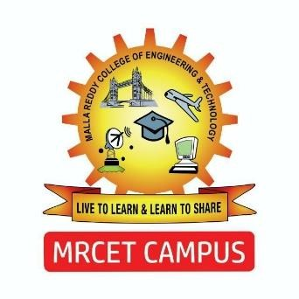

**DEPARTMENT OF AERONAUTICAL ENGINEERING**

**MALLA REDDY COLLEGE OF ENGINEERING AND TECHNOLOGY**

**(Autonomous Institution – UGC, Govt. of India)**

**(Affiliated to JNTU, Hyderabad, Approved by AICTE, Accredited by NBA & NAAC – ‘A’ Grade, ISO 9001:2015 Certified)** Maisammaguda (v), Near Dullapally, Via: Kompally, Hyderabad – 500 100, Telangana State, India **2022-2023**

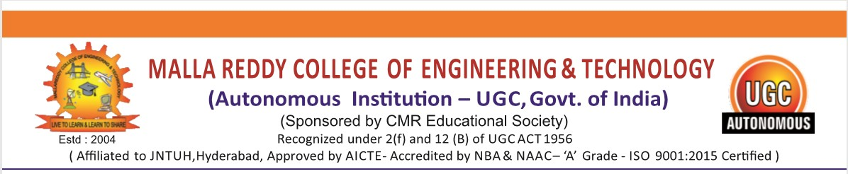CERTIFICATE

This is to certify that this is the bonafide record of the project titled **“Android Application to send SMS using Intent”** submitted by **Shaik Nawaz (20N31A2134)**, **Tirumala Sai Nithin (20N31A2135)** and **V Himabindu (20N31A2136)** of **B.Tech III Year – II Semester** in the partial fulfillment of the requirements for the degree of **Bachelor of Technology** in **Department of Aeronautical Engineering**, during the year 2022-2023. The results embodied in this project report have not been submitted to any other university or institute for the award of any degree or diploma.

**Mrs. L. Sushma**

Associate Professor

**Department of Aeronautical Engineering**

**EXTERNAL EXAMINER Dr. Misba Mehdi**

**Head of the Department**

**Department of Aeronautical engineering**

## ACKNOWLEDGEMENTS

We feel ourselves honored and privileged to place our warm salutation to our college “Malla Reddy College of Engineering and Technology (Autonomous Institution – UGC Govt. of India) and our Principal **Dr. S Srinivasa Rao,** Professor who gave us the opportunity to do the Application Development -2 during our III Year B.Tech and profound the technical skills.

We express our heartiest thanks to our Director **Dr. V S K Reddy,** Professor for encouraging us in every aspect of our project and helping us realize our full potential.

We are also thankful to our Head of the Department **Dr. Misba Mehdi,** Professor for providing training and guidance, excellent infrastructure and a nice atmosphere for completing this project successfully.

We would like to express our sincere gratitude and indebtedness to our project supervisor **Mrs. L. Sushma,** Professor for her valuable suggestions and interest throughout the course of this project.

We would like to thank all our supporting **staff** of the Department of Aeronautical Engineering and even all other departments who have been helpful directly and in-directly in making our project a success.

Finally, We would like to take this opportunity to thank our **families** for their support and blessings for completion of our project that gave us the strength to do our project.

**Shaik Nawaz**

**Tirumala Sai Nithin**

**V Himabindu**

**20N31A2134**

**20N31A2135**

**20N31A2136**

**DECLARATION**

We hereby declare that the project entitled **“Android Application to send SMS using Intent”** submitted to **Malla Reddy College of Engineering and Technology,** affiliated t**o** Jawaharlal Nehru Technological University Hyderabad (JNTUH) as part of III Year B.Tech – II Semester and for the partial fulfillment of the requirement for the award of **Bachelor of Technology** in **Aeronautical Engineering** is a result of original research work done by us.

It is further declared that the project report or any part there of has not been previously submitted to any University or Institute for the award of degree or diploma.

**Shaik Nawaz 20N31A2134**

**Tirumala Sai Nithin 20N31A2135**

**V Himabindu 20N31A2136**